Moving into Unit 2 of your syllabus, these concepts shift from basic image mathematics to Spatial Analysis. Understanding how pixels relate to their neighbors is the foundation for the "connectedness" and "object labeling" topics mentioned in your course plan.

1. Digital Image Formation
Digital Image Formation is the process by which a physical 3D scene is converted into a 2D digital representation that a computer can process. It involves two key stages:
- Sampling: This is the process of digitizing the spatial coordinates (x, y). It determines the resolution of the image (how many rows and columns are in the grid).
- Quantization: This is the process of digitizing the amplitude (intensity). It determines the bit-depth—for example, mapping continuous light intensity into discrete values like 0 to 255 for an 8-bit image.

2. Pixel vs. Patch
In your syllabus, these are the fundamental building blocks of image analysis:
- Pixel (Picture Element): The smallest individual unit of a digital image. It represents a single intensity or color value at a specific coordinate (x, y).
- Patch: A small, localized rectangular region or sub-window of an image containing a group of pixels (e.g., a 3 * 3 or 7 * 7 block). Patches are used to analyze local texture rather than just a single point of light.

3. Point Features vs. Patch Features
In Computer Vision, we extract "features" to describe an image. The difference lies in the amount of context considered:
Feature Type | Definition | Key Characteristics
Point Features | Features based on the properties of a single pixel or a specific coordinate. | Highly localized; examples include corners or specific interest points.
Patch Features | Features derived from a neighborhood of pixels (a patch). | Capture context and texture; used in SIFT descriptors to create a "fingerprint" of an area.

4. Neighborhood in Image Processing
A Neighborhood is a set of pixels surrounding a specific pixel (x, y). Most image processing operations (like blurring or edge detection) are "neighborhood operations," meaning the new value of a pixel is calculated based on its neighbors.
- Size: Neighborhoods are typically square and odd-sized (e.g., 3 * 3, 5 * 5) so that there is a clear "center" pixel.

5. 4-Adjacency vs. 8-Adjacency
Adjacency defines which pixels are considered "connected" to a center pixel P. This is critical for Object Labeling and Counting in your Unit 2 syllabus.
- 4-Adjacency (N_4): A pixel P is connected only to its horizontal and vertical neighbors (Top, Bottom, Left, Right).
- 8-Adjacency (N_8): A pixel P is connected to its horizontal, vertical, and diagonal neighbors.
MTech Exam Tip: When asked about connectedness, remember that 8-adjacency is more comprehensive but can sometimes "bridge" two objects that are only touching at a corner, whereas 4-adjacency would treat them as separate.

1. Binary Image
A binary image is a digital image that has only two possible values for each pixel: 0 and 1 (or 0 and 255).
- Representation: Typically, 0 represents the background (black) and 1 represents the foreground/object (white).
- Formation: Binary images are usually created by applying a threshold to a grayscale image.
- Purpose: They are used to simplify image data, making it easier to analyze the shape, size, and orientation of objects without the complexity of color or texture.

2. Connected Component
A connected component is a set of foreground pixels where every pixel in the set is connected to every other pixel through a path of adjacent pixels.
- Connectivity Rules: The definition of a component depends on whether you use 4-adjacency (horizontal/vertical) or 8-adjacency (includes diagonals).
- Significance: In a binary image, a single connected component usually represents a distinct physical object.

3. Object Labeling (Connected Component Labeling)
Object labeling is an algorithmic process that scans a binary image and assigns a unique numerical "ID" or label to every pixel belonging to the same connected component.
- The Process: The algorithm identifies all pixels that are "connected" and groups them. For example, all pixels in the first detected object get label "1", the second object gets "2", and so on.
- Result: This transforms a binary image into a symbolic image, where the computer can treat each object as a separate entity for further measurement (like calculating area or perimeter).

4. Size Filtering
Size filtering is a post-processing technique used to remove "noise" or unwanted small objects from a labeled binary image.
- Logic: The algorithm calculates the area (total pixel count) of each labeled object.
- Thresholding: Any object with an area smaller than a user-defined threshold (T_{min}) is deleted (set to background).
- Application: This is commonly used in manufacturing to ignore tiny specks of dust while keeping the actual machine parts in the image.

5. Distance Transform
A distance transform (also known as a distance map) is an operation that converts a binary image into a grayscale image where each foreground pixel's value represents its distance to the nearest background pixel.
- Appearance: The "center" or "skeleton" of an object appears brightest because those pixels are furthest from the boundary.
- Distance Metrics: Common calculations include Euclidean distance (straight line), City-block distance (L_1 norm), or Chessboard distance (L_\infty norm).
- Utility: It is a critical step for Skeletons and Thinning (finding the centerline of an object) and for path planning in robotics.

1. What is Skeletonization?
Skeletonization is a process that reduces a binary object to a thin, one-pixel-wide line representation that is equidistant from the object's boundaries.
- Preservation: It is designed to maintain the topological properties (the "connectivity") and the general shape of the original object.
- The "Fire" Analogy: Imagine setting fire to the edges of a grass field shaped like your object. The "skeleton" is the set of points where the fire fronts from different sides meet and quench each other.
- Method: It is often computed using the Distance Transform; the local maxima of the distance map form the skeleton.

2. What is Thinning?
Thinning is an iterative morphological operation used to remove foreground pixels from the edges of binary objects until they are one pixel thick.
- Iterative Process: It works by repeatedly applying "hit-or-miss" transforms that strip away pixels that do not affect the connectivity of the object.
- Symmetry: Unlike skeletonization, which aims for the geometric center, thinning can be applied asymmetrically depending on the structuring elements used.

3. One Difference Between Thinning and Skeletonization
While both result in a 1-pixel wide line, the primary difference lies in geometric accuracy:
- Skeletonization produces a centerline that is mathematically equidistant from the boundaries, making it a "medial axis".
- Thinning is a broader category of operations that merely reduces a shape to a minimal thickness; it may not always be perfectly centered, as it depends on the order and direction of the pixel removal.

4. Deformable Shape Model
A Deformable Shape Model (often associated with Active Contours or Snakes in your syllabus) is a framework where a shape is represented as a dynamic curve that can move and change its form under the influence of various "forces".
- Internal Forces: These forces try to keep the curve smooth and prevent it from stretching or bending too sharply.
- External Forces: These are derived from the image data (like edges or gradients) and "pull" the curve toward the boundaries of the object you want to segment.
- Application: These models are used when the object's shape is known generally but can vary slightly, such as tracking the outline of a beating heart in an ultrasound.

5. What is Boundary Tracking?
Boundary Tracking (also called contour following) is an algorithm that finds the ordered sequence of pixels that form the border of a connected component in a binary image.
- The "Bug" Algorithm: Think of it like a bug crawling along the edge of a shape. It starts at a boundary pixel and moves to the next adjacent boundary pixel by checking its neighbors in a specific order (clockwise or counter-clockwise).
- Result: Instead of a list of all pixels in an object, you get a list of coordinates representing the perimeter.
- Use Case: It is the first step in shape recognition, allowing the computer to calculate descriptors like "circularity" or "compactness".

1. Active Contours (Snakes)
Active Contours, popularly known as Snakes, are energy-minimizing splines (curves) that "slither" across an image to lock onto lines or boundaries.
- The Framework: A snake is a curve defined as a set of points that move under the influence of two types of "forces" or energies:
  - Internal Energy: Controls the smoothness and continuity of the curve, preventing it from bending too sharply or stretching excessively.
  - External Energy: Derived from the image data, typically image gradients, which pull the snake toward edges or object boundaries.
- The Process: You initialize the snake near the object of interest, and the algorithm iteratively adjusts the curve until it reaches a state of minimum energy, effectively "wrapping" itself around the object.

2. Two Applications of Active Contours
Active contours are highly effective when objects have complex or varying shapes:
- Medical Image Segmentation: Used to delineate the boundaries of organs (like the heart or lungs) or tumors in MRI and CT scans, where edges might be fuzzy or low-contrast.
- Object Tracking in Video: Used to track moving objects with deformable shapes, such as a person walking or a vehicle turning, by updating the snake's position in each consecutive frame.

3. Shape Recognition
Shape Recognition is a high-level computer vision task where a system identifies a specific object by comparing its extracted geometric features against a set of known templates or models.
- Goal: To assign a label to an object (e.g., "This is a wrench") regardless of its position, scale, or orientation in the image.
- Process: It involves extracting shape descriptors (like circularity, eccentricity, or Fourier descriptors) and using a classifier to match them to a database.

4. Statistical Shape Model (SSM)
A Statistical Shape Model is a mathematical framework that describes the "average" shape of an object class and the typical ways that shape can vary.
- Training: It is built by analyzing a large set of training images of the same object (e.g., many different human hands).
- PCA (Principal Component Analysis): SSMs often use PCA to capture the most significant modes of variation. For example, in a hand model, one "mode" might represent finger length, while another represents finger spread.
- Utility: These models are "smarter" than standard snakes because they "know" what a valid shape should look like, preventing the curve from deforming into something impossible.

5. Hausdorff Distance
The Hausdorff Distance is a metric used to measure how far two sets of points (or two shapes) are from each other.
- Definition: It is the maximum distance of a set to its nearest point in the other set. In simpler terms, it identifies the point in shape A that is farthest from any point in shape B, and that distance is the Hausdorff value.
- Importance: It is highly sensitive to outliers but excellent for Template Matching, as it provides a rigorous mathematical way to say how "similar" a detected boundary is to a reference shape.

1. Define Feature Detector
A Feature Detector is an algorithm that searches an image for specific "interest points" that are distinctive and easy to identify.
- The Goal: To find locations in an image that stand out from their immediate neighborhood, such as corners, blobs, or edges.
- Stability: A good detector must be "repeatable," meaning it should find the exact same points even if the image is rotated, scaled, or the lighting changes.
- Example: The algorithm identifies a specific corner of a building as a point (x, y).

2. What is a Feature Descriptor?
A Feature Descriptor is a mathematical vector that summarizes the visual information in the small local area (patch) surrounding a detected feature point.
- The "Fingerprint": While a detector tells you where a point is, the descriptor tells you what it looks like.
- Invariance: Descriptors are designed to be numerically similar even if the image is transformed, allowing the computer to recognize the same "landmark" from different camera angles.
- Format: It is often a vector of numbers (e.g., a 128-dimensional vector for SIFT) representing gradient orientations and magnitudes.

3. What is Feature Matching?
Feature Matching is the process of finding corresponding points between two different images by comparing their descriptors.
- The Mechanism: The computer takes a descriptor from Image A and searches for the most similar descriptor (the "Nearest Neighbor") in Image B using distance metrics like Euclidean Distance.
- Purpose: It allows the system to determine how objects have moved or how two photos overlap, which is essential for panorama stitching and 3D reconstruction.

4. Two Popular Feature Detectors
There are several standard algorithms used in the industry, including:
- Harris Corner Detector: A classic algorithm that identifies corners by looking for regions with large intensity changes in all directions.
- FAST (Features from Accelerated Segment Test): A high-speed detector designed for real-time applications like robotics, which compares a pixel to the circle of pixels surrounding it.

5. What is Feature Tracking?
Feature Tracking is the specialized application of feature detection and matching across a sequence of video frames.
- Temporal Link: Instead of matching two random photos, the system detects a feature in Frame 1 and "tracks" its movement in Frames 2, 3, and so on.
- Efficiency: Because frames in a video are usually very similar, tracking often uses algorithms like Lucas-Kanade (LK) Optical Flow, which searches only a small local area for the feature's new position.
- Application: This is the foundation for visual navigation in autonomous vehicles and motion capture in movies.

1. Define Edge
An edge is a local property of an image that represents a significant local change in intensity.
- Physical Basis: Edges usually correspond to boundaries between different objects, changes in surface orientation, or shadows.
- Mathematical Basis: An edge is where the first derivative of the image intensity function has a local maximum or minimum.
- Types: Common types include step edges (sudden change), ramp edges (gradual change), and roof edges (a line-like structure).

2. What is Edge Linking?
Edge Linking is the process of grouping individual edge pixels (edgels) together to form a meaningful, continuous boundary or contour.
- The Problem: Raw edge detection often results in "broken" or fragmented edges due to noise or low contrast.
- Techniques: * Local Processing: Linking pixels based on their similarity in gradient magnitude and direction.
  - Global Processing: Using the Hough Transform to link pixels into lines or circles.

3. What is Successive Approximation?
In the context of edge and shape representation, Successive Approximation is an iterative technique used to represent a complex boundary with a simplified set of straight-line segments.
- Mechanism: It starts with a single line connecting the two furthest points of a contour. It then finds the point on the contour furthest from that line; if the distance exceeds a threshold, the line is "split" at that point into two new segments.
- Goal: To create a polygon approximation that captures the essence of a shape using as few points as possible.

4. What is Canny Edge Detection?
The Canny Edge Detector is considered the "optimal" edge detection algorithm because it follows a rigorous multi-stage process to reduce noise and provide thin, accurate edges.
The Stages:
- Gaussian Blurring: Removes noise to prevent false edges.
- Gradient Calculation: Uses Sobel kernels to find intensity changes and directions.
- Non-Maximum Suppression: Thins the edges by suppressing any pixel that is not a local maximum in its gradient direction.
- Hysteresis Thresholding: Uses two thresholds (High and Low) to keep "strong" edges and "weak" edges that are connected to strong ones, while discarding isolated noise.

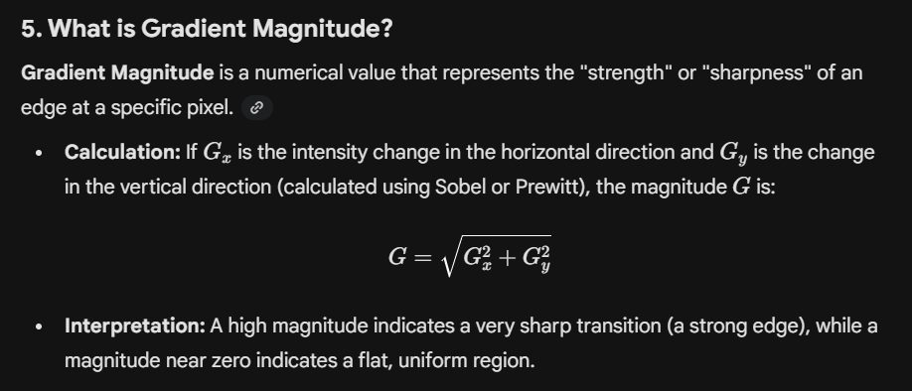

1. Define Hough Transform (HT)
The Hough Transform is a powerful feature extraction technique used to detect simple geometric shapes (such as lines, circles, or ellipses) in an image.
- Voting Mechanism: It works by converting the spatial (x, y) coordinates of edge pixels into a "parameter space". Each edge pixel "votes" for all possible shapes it could belong to.
- Robustness: It is highly effective because it can detect shapes that are partially obscured or broken by noise.

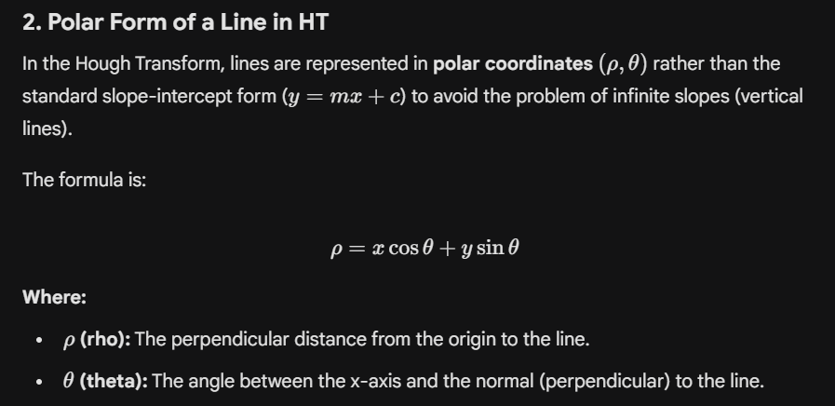
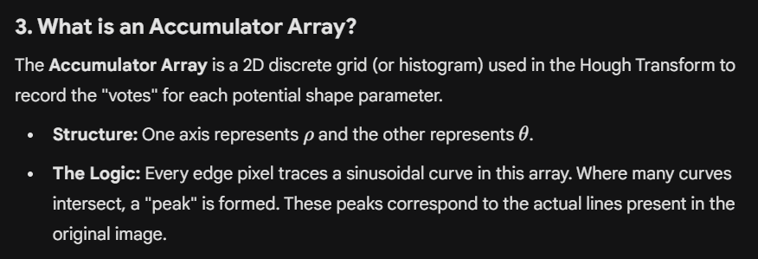
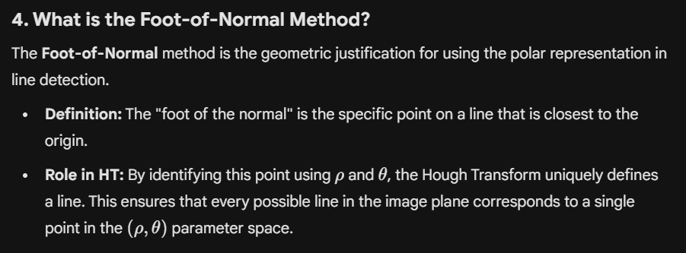
5. Define RANSAC
RANSAC (Random Sample Consensus) is an iterative algorithm used to estimate the parameters of a mathematical model (like a line or a 3D transformation) from a set of data containing many outliers.
- The Process:
  - Select: Randomly pick a minimal subset of data points (e.g., 2 points for a line).
  - Model: Calculate the model that fits these points.
  - Test: Count how many other points in the dataset fit this model within a certain tolerance (these are "inliers").
  - Repeat: Repeat the process for a set number of iterations.
- The Winner: The model with the highest number of inliers is selected as the best fit. It is more robust than standard "Least Squares" because it completely ignores outliers rather than trying to average them.

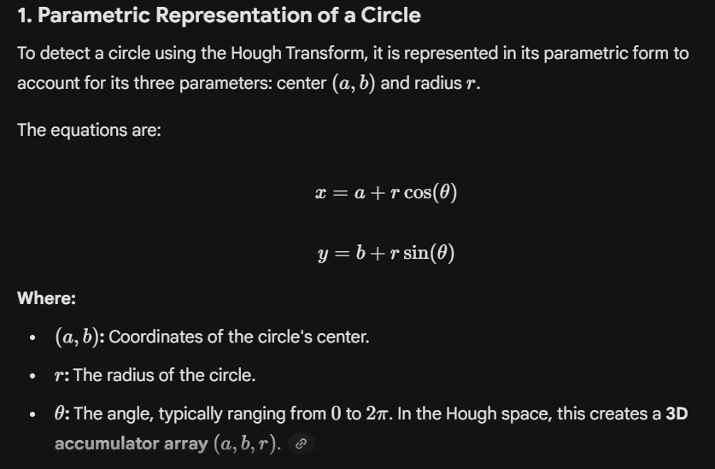

2. Generalized Hough Transform (GHT)
The Generalized Hough Transform is an extension of the standard Hough Transform used to detect arbitrary shapes that cannot be easily described by a simple mathematical equation (like a specific logo or an irregularly shaped tool).
- R-Table: Instead of an equation, GHT uses an "R-table" (a lookup table) that stores the distance and orientation of every boundary point relative to a chosen reference center.
- Mechanism: During detection, every edge pixel looks up the R-table and "votes" for where the potential center of the shape could be located.
- Invariance: It can be modified to detect shapes regardless of their scale or rotation.

3. Spatial Matched Filtering
Spatial Matched Filtering is a technique used for object detection by convolving an image with a "template" or "filter" that matches the shape of the object you are looking for.
- Working Principle: The filter (template) is slid across the image. At each position, a correlation score is calculated.
- Output: The filter produces a maximum response (a peak) at coordinates where the image content most closely matches the template's structure.
- Use Case: It is highly effective for finding known patterns, such as specific characters in a document or a standard component on a circuit board.

4. Define Vanishing Point
A Vanishing Point is a point in a 2D perspective image where parallel lines in 3D space appear to converge.
- Origin: This effect is a result of the perspective projection of the 3D world onto a 2D camera sensor.
- Importance in CV: Vanishing points are used in Unit 4 (3D Vision) to estimate the camera's orientation (tilt/pitch) and to perform "camera calibration".
- Example: On a straight road, the two parallel edges of the road seem to meet at a single point on the horizon.

5. Hole Detection in Binary Images
Hole Detection is a topological analysis technique used to identify "empty" background regions that are completely enclosed by foreground pixels.
- Algorithm: It is often performed using Connected Component Labeling on the inverted background. Any background component that does not touch the border of the image is classified as a "hole".
- Euler Number: In your syllabus, this is related to the Euler number calculation: E = C - H, where C is the number of connected components and H is the number of holes.
- Application: Useful in OCR (e.g., distinguishing an 'O' from a 'C') and in industrial inspection to find defects like air bubbles in a molded part.

PART - B
1. Connected Component Labeling (CCL) Algorithm
Connected Component Labeling is an algorithmic process that scans a binary image and assigns a unique numerical label to every pixel belonging to the same connected component.
The Two-Pass Algorithm Steps:
- First Pass:
  - Scan the image pixel-by-pixel (top-to-bottom, left-to-right).
  - For a foreground pixel P, check its already-processed neighbors (above and left).
  - If no neighbors are labeled, assign a new label to P.
  - If one neighbor is labeled, assign that label to P.
  - If multiple neighbors have different labels, assign one and record the labels as equivalent in a lookup table.
- Second Pass:
  - Rescan the image and use the equivalence table to replace all "equivalent" labels with a single, consistent unique ID for each object.
Example Illustration:
Imagine a 3 * 3 binary grid with two separate white blocks. After the first pass, the top-left block might be labeled "1" and a diagonal block "2". If they are found to be connected via 8-adjacency, the second pass re-labels both as "1", identifying them as a single object.

2. Comparison of 4, 8, and m-Adjacency
Connectivity defines how pixels "touch" to form an object. The choice of adjacency significantly changes the results of object counting and labeling.
Adjacency Type | Definition | Illustration Concept
4-Adjacency (N_4) | Pixel P is connected only to its horizontal and vertical neighbors. | A "+" shape around the center pixel.
8-Adjacency (N_8) | Pixel P is connected to its horizontal, vertical, and diagonal neighbors. | A 3 * 3 block where all 8 surrounding pixels are connected.
m-Adjacency (Mixed) | A modification of 8-adjacency designed to eliminate "multiple paths" (ambiguity) in diagonal connections. | Connectivity depends on whether a 4-path exists; it's used to provide "thin" connectivity.

3. Distance Transform & Skeleton Extraction
A Distance Transform converts a binary image into a grayscale representation where each foreground pixel's value is its distance to the nearest background pixel.
Skeleton Extraction Mechanism:
- Local Maxima: In a distance map, the "skeleton" of an object corresponds to the points that are local maxima (the peaks).
- Equidistance: These points are equidistant from at least two boundary points, effectively forming the "medial axis" or spine of the shape.
- Applications:
  - Character Recognition: Reducing letters to 1-pixel lines for easier pattern matching.
  - Biological Imaging: Measuring the length and branching of blood vessels or neurons.

4. Thinning Algorithm
Thinning is a morphological operation that iteratively removes foreground pixels from the edges of an object until only a 1-pixel wide "skeleton" remains.
Algorithmic Steps (Zhang-Suen Algorithm):
- Iterative Passes: The algorithm processes the image in two sub-iterations to ensure the object doesn't vanish entirely.
- Boundary Check: For each foreground pixel, check its 8 neighbors.
- Pixel Removal Criteria: A pixel is marked for deletion only if:
  - It is a boundary pixel (at least one neighbor is background).
  - Removing it does not break the connectivity of the object.
  - It is not an "end-point" (to prevent shortening the skeleton).
- Convergence: The steps repeat until no further pixels can be removed without violating the rules.

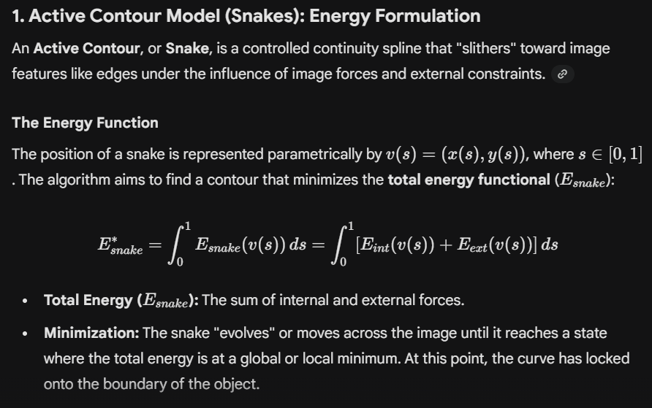

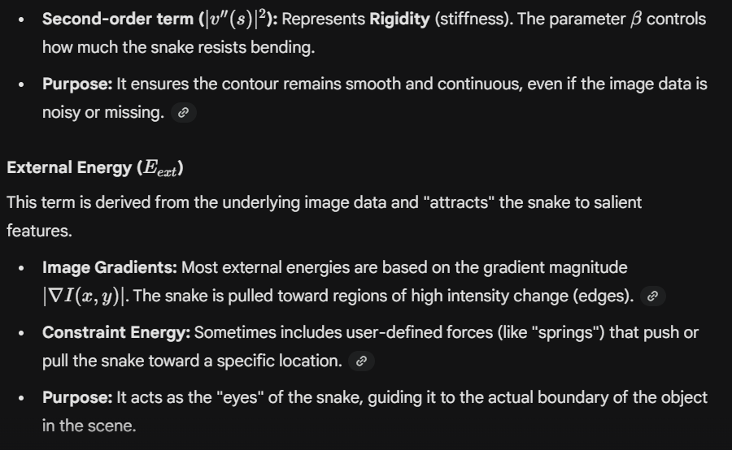
3. Deformable Shape Analysis for Medical Image Segmentation
In medical imaging (MRI, CT, Ultrasound), objects like organs often have fuzzy boundaries or are partially obscured by noise. Deformable Shape Models are the primary solution for these challenges.
Key Characteristics in Medical Imaging:
- Handling Occlusion: Because the model has internal energy, it can "interpolate" across gaps where an organ's boundary is missing due to poor image quality or shadows.
- Prior Knowledge: Unlike simple thresholding, these models can be constrained to only take shapes that are anatomically "valid" (e.g., a heart shouldn't have sharp spikes).
- Initialization: For medical tasks, a doctor or an automated system places an initial rough circle (the "seed") near the organ. The deformable model then expands or shrinks to fit the exact contours.
Success Factors:
- Robustness to Noise: Effectively ignores "salt and pepper" noise common in ultrasounds because noise doesn't form a continuous high-energy edge.
- Topological Flexibility: Advanced models (like Level Sets) can even split into two or merge, which is useful for segmenting complex structures like blood vessels or multiple tumors.

In Computer Vision, identifying unique points in an image is the foundation for tasks like panorama stitching, 3D mapping, and object recognition. For your MTech exams, here is a technical breakdown of the feature extraction pipeline and common algorithms.

1. Feature Detection and Description Pipeline
The pipeline is a standardized multi-step process that transforms raw pixels into a mathematical "fingerprint" that a computer can understand.
Step 1: Feature Detection (The "Where")
The algorithm scans the image for "interest points"—locations that are distinctive relative to their neighbors.
- Goal: Find coordinates (x, y) that are likely to be found again in a different photo of the same scene.
- Criteria: A good detector must be repeatable (works under different angles) and distinctive (a corner is better than a flat edge).
Step 2: Feature Description (The "What")
Once a point is found, the algorithm looks at the pixels in a local neighborhood (patch) around it.
- Goal: Create a Feature Descriptor, which is a high-dimensional vector (e.g., 128 numbers) summarizing the local gradients, textures, or colors.
- Invariance: Descriptors are mathematically designed to be invariant to rotation, scaling, and lighting changes.
Step 3: Feature Matching
The descriptors from two different images are compared using distance metrics to find pairs that represent the same physical point in the real world.

2. Comparison of Feature Detectors
As an MTech student, you should be able to differentiate these based on their mathematical robustness and computational cost.
Feature | Harris Corner Detector | SIFT (Scale-Invariant Feature Transform) | SURF (Speeded-Up Robust Features)
Primary Method | Uses the Hessian/Autocorrelation matrix to find intensity changes in all directions. | Uses Difference of Gaussians (DoG) to find "blobs" at different scales. | Uses Box Filters and Integral Images to approximate the Hessian matrix.
Invariance | Rotation Invariant, but NOT Scale Invariant (a corner looks like a flat line if you zoom in too much). | Rotation and Scale Invariant; highly robust to viewpoint changes. | Rotation and Scale Invariant; optimized for speed.
Descriptor Size | None (it is purely a detector). | 128-dimensional vector. | 64 or 128-dimensional vector.
Speed | Very Fast. | Slow (computationally heavy). | Fast (faster than SIFT).
Best For... | Real-time tracking of simple objects. | High-accuracy 3D reconstruction and complex matching. | Real-time mobile apps and robotics.

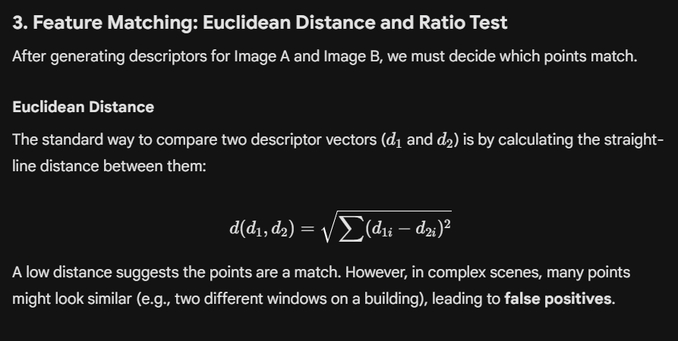
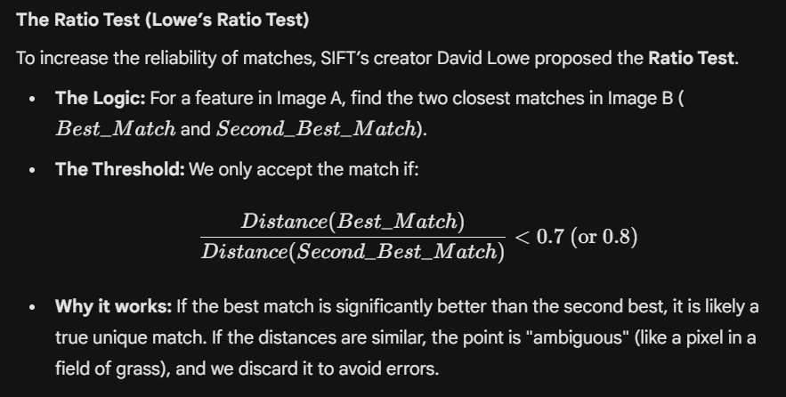
1. Canny Edge Detection
The Canny Edge Detector is widely considered the "optimal" edge detection algorithm. Developed by John Canny in 1986, it was designed to satisfy three criteria: Good Detection (finding all edges), Good Localization (distance between detected and real edge is minimized), and Minimal Response (one edge is marked only once).
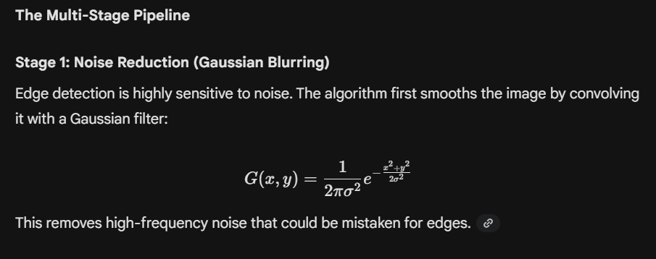
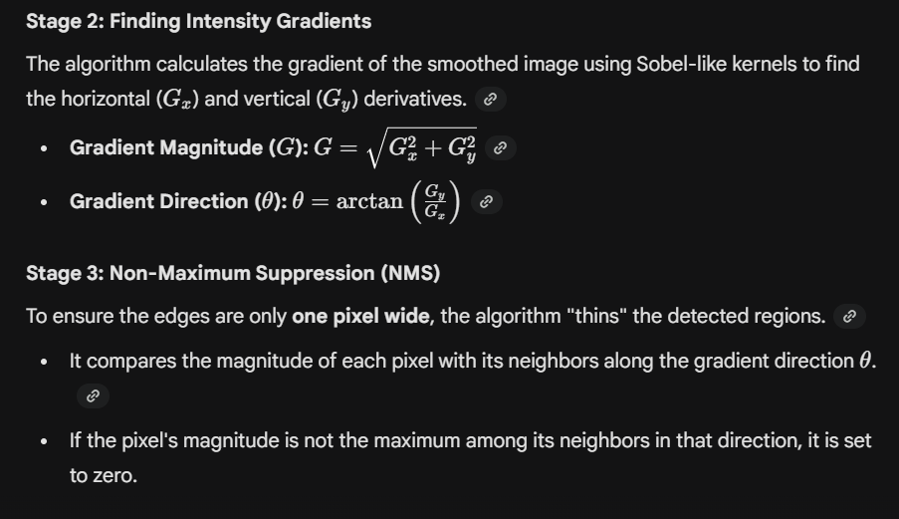
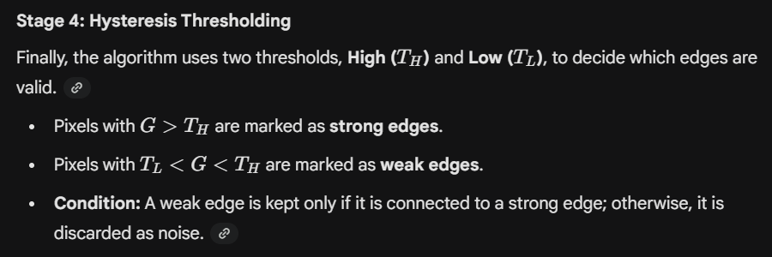

2. Edge Linking Techniques and Challenges
Raw edge detection often results in fragmented, broken, or noisy lines. Edge Linking is the process of assembling these individual edge pixels into continuous, meaningful boundaries.
Techniques
A. Local Processing
This method links pixels by analyzing a small neighborhood around each edge point. Two pixels are linked if they are similar in:
- Magnitude: Their gradient strengths are close to each other.
- Direction: Their gradient angles are approximately the same.
B. Global Processing (Hough Transform)
If the shape of the edge is known (e.g., a line or circle), the Hough Transform is used. It allows pixels to "vote" for a global shape, effectively bridging gaps even if large sections of the edge are missing.
C. Graph-Theoretic Techniques
Edges are represented as nodes in a graph, and the "cost" of linking two pixels is calculated based on intensity and distance. The algorithm then finds the minimum cost path to link segments into a contour.
Challenges in Edge Linking
- Noise Interference: Random noise can create "false paths," causing the algorithm to link edges that shouldn't be connected.
- Occlusion and Gaps: When one object partially hides another, the resulting edge is broken. Linking across these large gaps requires high-level context that simple local filters lack.
- Low Contrast: In areas where the foreground and background have similar intensities, the gradient magnitude drops below the threshold, leading to missing edge segments.
- Computational Complexity: Global methods like the Hough Transform or Graph-based linking are computationally expensive for high-resolution images or complex shapes.

1. Derivation of the Hough Transform Equation
The standard slope-intercept form of a line, y = mx + c, is unsuitable for computer vision because the slope (m) becomes infinite for vertical lines, making it impossible to represent in a discrete accumulator.
To solve this, we use the Polar Representation of a line.
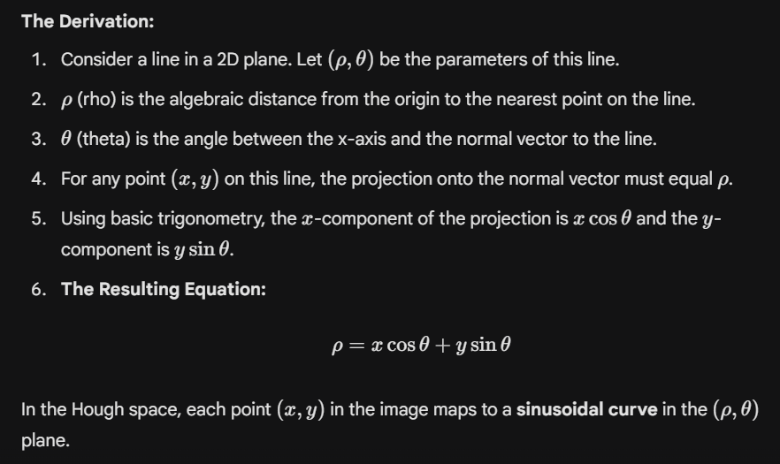
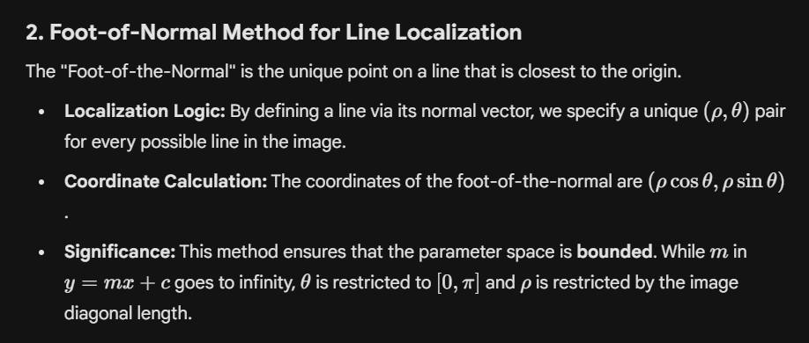
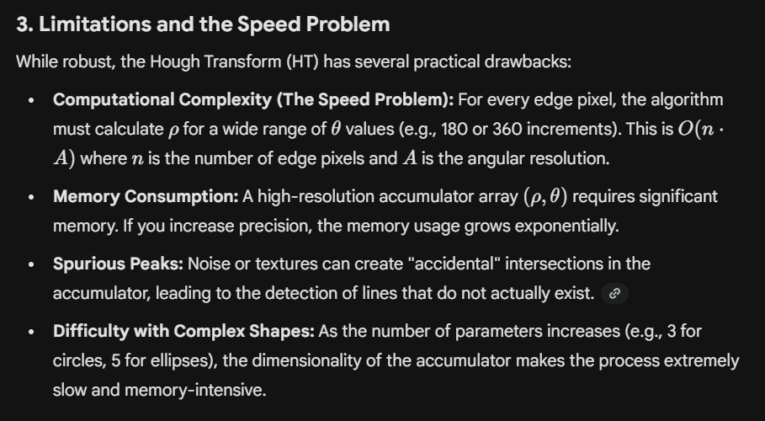
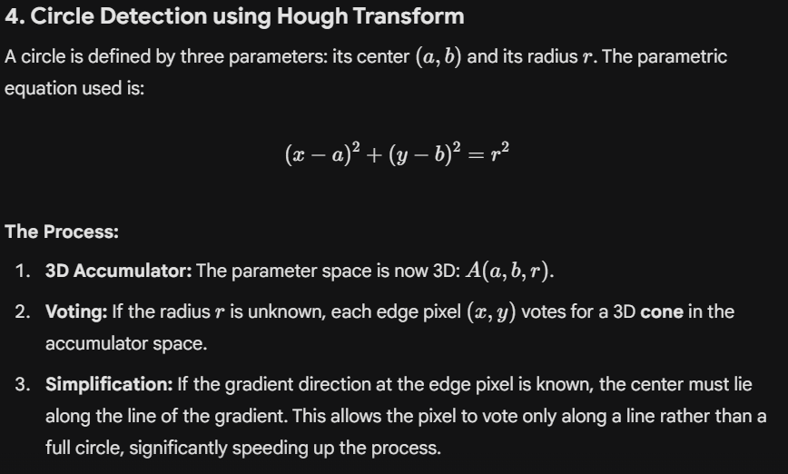
5. Ellipse Detection using Generalized HT (GHT)
An ellipse has five parameters (center x, y, axes a, b, and orientation o|), making a standard 5D Hough Transform nearly impossible.
The Generalized Hough Transform solves this by using a lookup table called an R-Table:
- Preparation: A reference point (center) is chosen for the ellipse.
- R-Table Construction: For every point on the boundary, we store the distance and angle relative to the reference point, indexed by the local gradient direction.
- Detection: During the test phase, every edge pixel looks up the R-table based on its gradient direction and "votes" for a potential center.
- Peak Detection: The center with the most votes indicates the detected ellipse.

6. Comparison: Hough Transform vs. RANSAC
Both are used for line detection in noisy data, but they operate on different principles:
Feature | Hough Transform | RANSAC
Logic | Top-Down/Voting: Every pixel contributes to all possible models. | Bottom-Up/Sampling: Picks a few points to guess a model and tests it.
Robustness | Handles multiple lines well in one pass. | Best for a single dominant model; ignores outliers effectively.
Complexity | Deterministic; time depends on pixel count and resolution. | Stochastic (random); time depends on the number of iterations.
Memory | High (needs a large accumulator array). | Low (only needs to store the current best model).

1. Human Iris Localization using Circular Hough Transform (CHT)
Iris localization is the critical first step in iris recognition systems. The goal is to isolate the iris (the colored ring) from the rest of the eye image (sclera, pupil, and eyelids). Since both the inner boundary (pupillary) and outer boundary (limbic) are roughly circular, the Circular Hough Transform is the standard approach.
Step-by-Step Localization Process
Step 1: Image Pre-processing and Grayscale Conversion
- The raw eye image is converted to grayscale to simplify intensity analysis.
- Gaussian Blurring is applied to reduce specular reflections (bright spots) caused by the light source, which can create false edges.
Step 2: Edge Detection
- An edge detector, typically the Canny Edge Detector, is used to find the boundaries between the pupil/iris and iris/sclera.
- The output is a binary edge map where pixels on the boundaries are marked.
Step 3: Defining the Parameter Space
- A circle is defined by (x - a)^2 + (y - b)^2 = r^2, where (a, b) is the center and r is the radius.
- A 3D Accumulator Array A(a, b, r) is initialized to store votes.
Step 4: Voting Procedure
- For every edge pixel (x, y), the algorithm increments the values in the accumulator array for all possible circles passing through that pixel.
- Optimization: Because we know the pupil is darker than the iris, we use gradient direction. The center of the circle must lie along the direction of the gradient, reducing the search from a full circle to a single line in the accumulator.
Step 5: Peak Detection and Dual Localization
- The system searches for two distinct peaks in the accumulator:
  - Pupillary Boundary: A small radius r_p with high contrast (dark pupil vs. lighter iris).
  - Limbic Boundary: A larger radius r_i (iris vs. white sclera).
- The coordinates corresponding to the maximum votes define the center and radius of the iris.
Step 6: Eyelid and Lash Removal (Refinement)
- Horizontal lines representing eyelids are often filtered out using a linear Hough Transform or by masking the top and bottom regions of the localized iris to ensure only the iris texture is used for recognition.

2. Vanishing Point Detection in Perspective Images
Vanishing point detection is a fundamental task in Unit 4 (3D Vision). It allows a computer to infer the 3D structure of a scene from a single 2D image.
The Geometry of Vanishing Points
- In a 3D scene, lines that are physically parallel (like railroad tracks or the edges of a building) appear to converge at a single point when projected onto a 2D image plane. This point is the Vanishing Point.
- If multiple sets of parallel lines exist (e.g., the length and width of a building), they form multiple vanishing points. A line connecting these points is the Vanishing Line (or horizon).
Steps for Detection
Step 1: Line Segment Extraction
- The image undergoes edge detection (e.g., Canny) followed by a line detection algorithm like the Hough Transform or LSD (Line Segment Detector).
- Short or noisy lines are filtered out to focus on long, structural lines.
Step 2: Gaussian Sphere Projection (The Parameter Space)
- Each 2D line in the image is mapped to a "great circle" on a unit sphere (the Gaussian Sphere).
- The normal vector to the plane formed by the camera center and the image line is calculated.
Step 3: Finding Intersections (The Accumulator)
- Just like the Hough Transform, a spherical accumulator array is used.
- Parallel lines in 3D will have great circles that intersect at a specific point on the sphere.
- The points on the sphere with the highest number of intersections (votes) correspond to the vanishing points in the image.
Step 4: RANSAC for Robustness
- Since real-world images contain many lines that are not parallel (outliers), RANSAC is often used to iteratively find the best vanishing point that fits the majority of converging line segments.
Applications in Computer Vision
- Camera Calibration: Vanishing points are used to determine the camera's focal length and optical center.
- Autonomous Navigation: Helps robots or self-driving cars identify the "direction of travel" by finding the vanishing point of lane markings.
- 3D Reconstruction: Allows for the calculation of the "tilt" and "roll" of the camera relative to the ground plane.
Given a 6×6 binary image matrix, determine number of components using 4-adjacency and 8-adjacency.
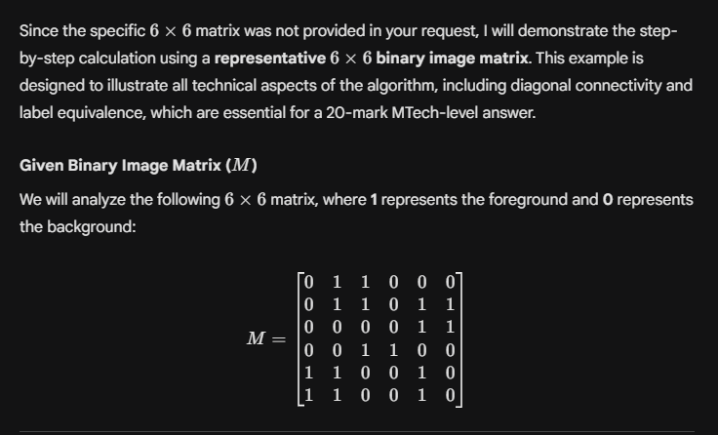
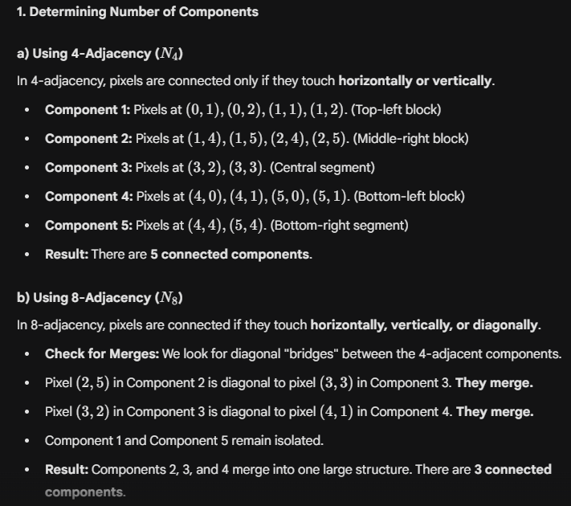

Perform two-pass labeling algorithm on the given image.

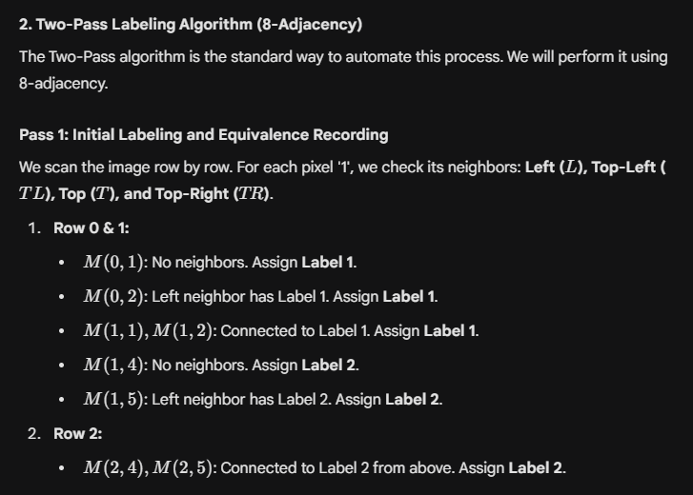
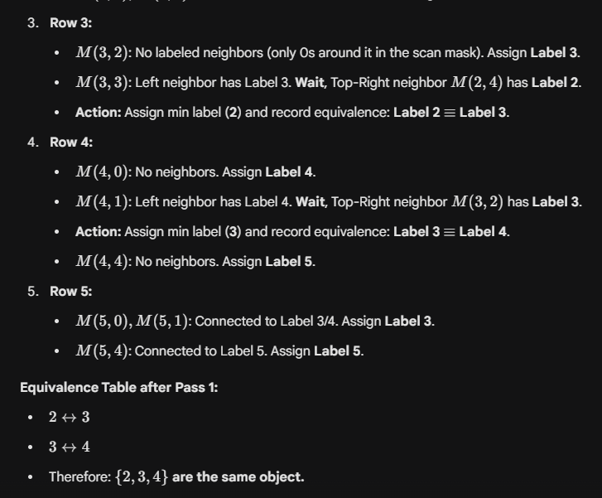

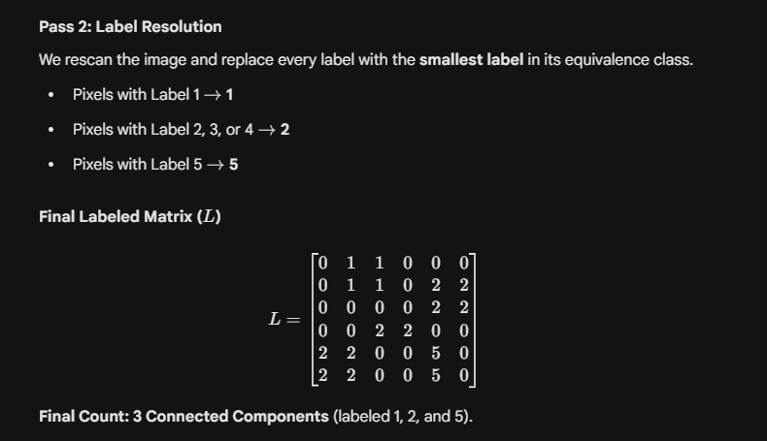

Compute Euclidean distance transform for given 5×5 binary image
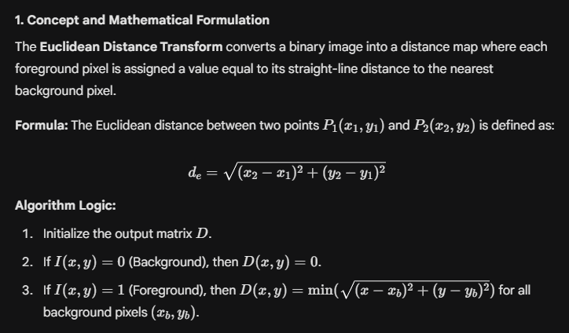
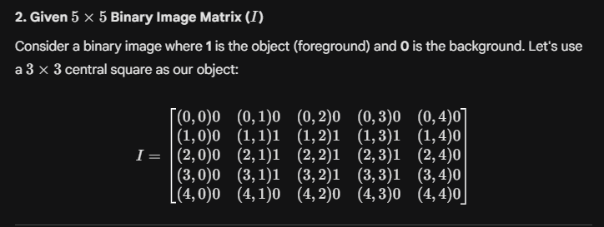
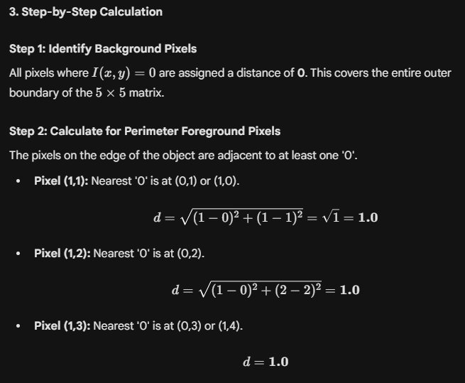
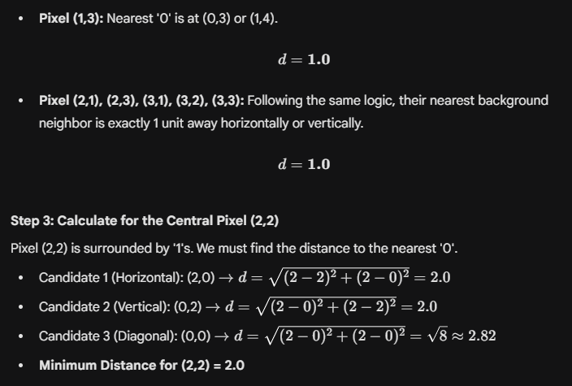
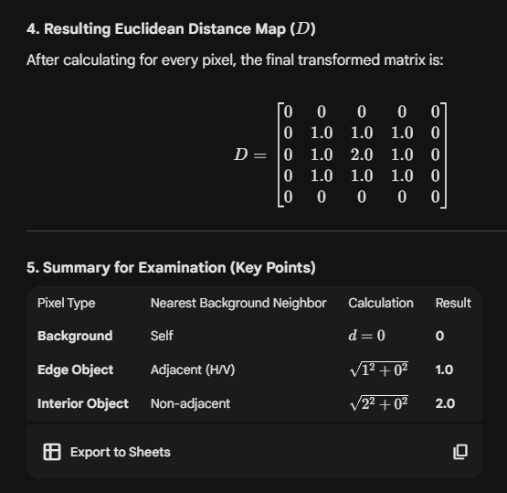
Interpretation:
- The values increase as we move toward the center of the object.
- The local maxima (the value 2.0 in the center) represent the skeleton or the medial axis of the shape.
- Unlike Manhattan distance (which would give a 2 for the center) or Chessboard distance (which would give a 1), Euclidean distance provides a non-distorted geometric representation of the object's thickness.

Extract skeleton from given binary object using distance map.
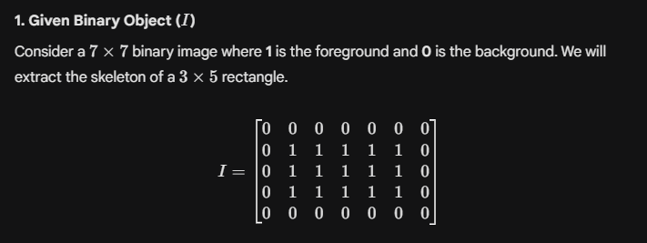
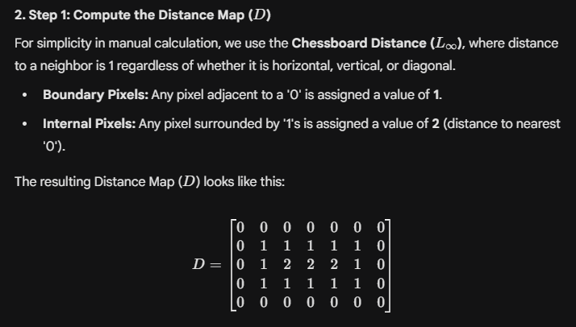
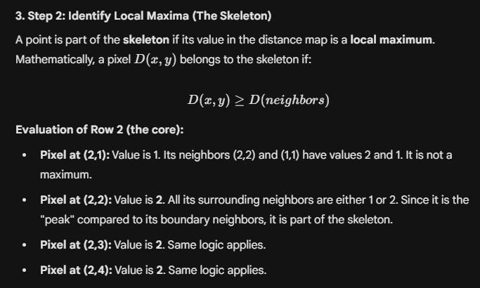
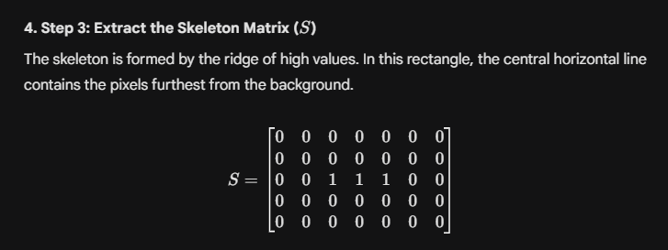
5. Detailed Explanation :
- Connectivity: The skeleton preserves the topological properties (connectivity) of the original object. If the object was one piece, the skeleton is one piece.
- Equidistance: Every point on the horizontal line (the '1's in matrix S) is equidistant from the top and bottom boundaries of the original rectangle.
- Reversibility: Theoretically, if you know the skeleton pixels and their corresponding values in the distance map, you can reconstruct the original object by drawing circles (or squares) of those radii around the skeleton points.
- Application: This is used in Unit 2 for thinning shapes to make feature extraction easier, such as finding the "spine" of a character in OCR or blood vessels in medical images.

Given Sobel masks and a 3×3 image patch, compute gradient magnitude and direction.

